1DoF and 6DoF platform

Combined system

The method used to align inputs and outputs and to calculate the latency between the two systems is based on calculating RMSE between the interpolated input and output.

A list of shifts is tested and for each shift, the RMSE between the interpolated input and output values between 0 and 299.8 s is calculated. The optimal shift is given by the minimal RMSE value. The latency between the two systems is the difference between 6D and 1D optimal shifts.

Summary of the 5 traces 1

1.Mean_Motion 3

0.2s delay 3

0.4s delay 3

2.Mean_Motion2 4

0.2s delay 4

0.4s delay 5

3.High_Motion 6

0.2s delay 6

0.4s delay 7

4.Mean_Complexity 7

0.2s delay 8

0.4s delay 8

5.High_Complexity 8

0.2s delay 9

0.4s delay 9

# **Summary of the 5 traces**

|  |  |  |
| --- | --- | --- |
|  | **Frequency : 0.2s delay** | |
|  | **1DoF** | **6Dof** |
| Mean (mm) | 0.2 | 0.1 |
| Std (mm) | 1.6 | 0.6 |
| 1st percentile (mm) | -3.3 | -2.0 |
| 99th percentile (mm) | 4.0 | 1.8 |
| Latency mean – rmse method (s) | **0.13** | |
| Latency mean - 1st peak method (s) | **0.16** | |
| Latency std (s) | **0.18** | |
| Latency min (s) | **-0.09** | |
| Latency max (s) | **0.34** | |

# **1.Mean_Motion**

|  |  |  |
| --- | --- | --- |
| mm | **1DoF (0.2s)** | **6DoF** |
| **Mean** | 0.3 | 0.0 |
| **Std** | 2.4 | 0.9 |
| **1st percentile** | -4.4 | -2.0 |
| **99th percentile** | 6.0 | 1.9 |
| **Latency of the combined system (s)** | | |
| **Mean (RMSE method)** | 0.34 | |
| **Mean (1st peak method)** | 0.28 | |

## 0.2s delay

|  |  |  |  |  |  |  |
| --- | --- | --- | --- | --- | --- | --- |
|  | **1DoF platform (0.2s)** | | | **6DoF platform** | | |
| Tests | Test 1 | Test 2 | Test 3 | Test 1 | Test 2 | Test 3 |
| Mean (mm) | 0.4 | 0.3 | 0.3 | -0.0 | 0.0 | 0.0 |
| Std (mm) | 2.3 | 2.5 | 2.5 | 0.8 | 0.9 | 0.9 |
| 1st percentile (mm) | -4.1 | -4.5 | -4.6 | -1.8 | -1.9 | -2.5 |
| 99th percentile (mm) | 5.7 | 6.1 | 6.1 | 1.8 | 2.0 | 1.8 |
| Latency (RMSE) (s) | 0.44 | 0.18 | 0.39 |  | | |
| Latency (1st peak) (s) | 0.35 | 0.15 | 0.35 |  | | |

## 0.4s delay

|  |  |  |  |  |  |  |
| --- | --- | --- | --- | --- | --- | --- |
|  | **1DoF platform (0.4s)** | | | **6DoF platform** | | |
| Tests | Test 1 | Test 2 | Test 3 | Test 1 | Test 2 | Test 3 |
| Mean (mm) | 0.8 | 1.5 | 0.8 | -0.7 | -0.6 | -0.9 |
| Std (mm) | 3.39 | 3.9 | 2.6 | 2.4 | 2.8 | 1.6 |
| 1st percentile (mm) | -7.2 | -7.3 | -6.1 | -5.6 | -6.3 | -5.0 |
| 99th percentile (mm) | 8.8 | 10.8 | 7.5 | 4.3 | 4.9 | 2.9 |
| Latency (RMSE) (s) | 0.17 | 0.41 | 0.4 |  | | |
| Latency (1st peak) (s) | 0.17 | 0.41 | 0.4 |  | | |

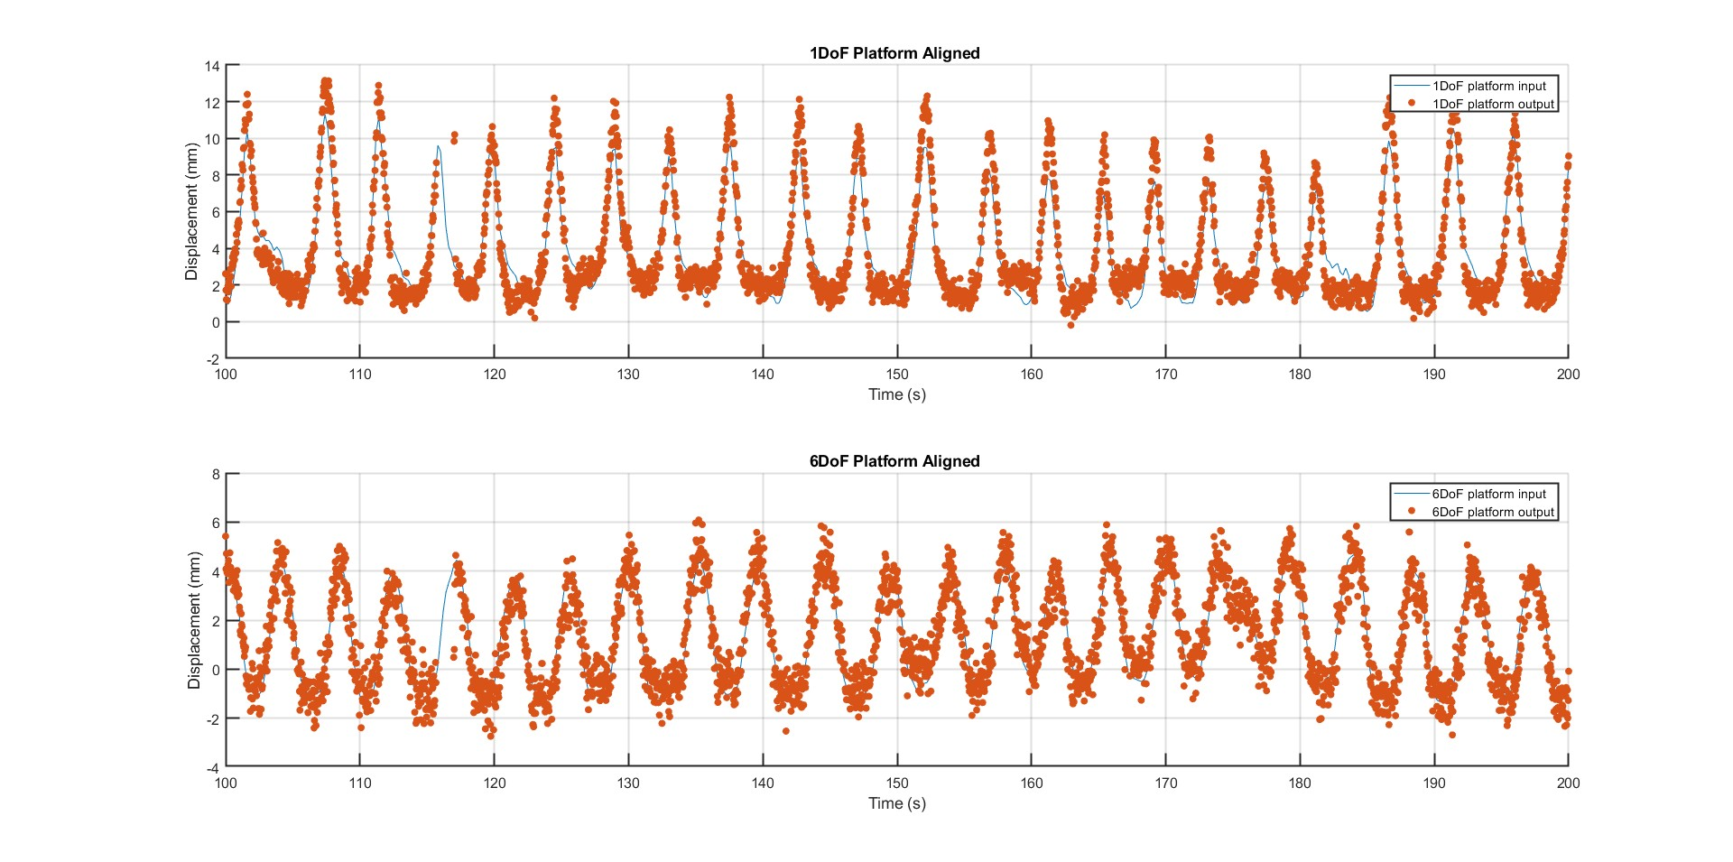

# **2.Mean_Motion2**

|  |  |  |
| --- | --- | --- |
| mm | **1DoF (0.2s)** | **6DoF** |
| **Mean** | 0.2 | -0.1 |
| **Std** | 1.3 | 1.0 |
| **1st percentile** | -2.7 | -3.2 |
| **99th percentile** | 3.0 | 1.9 |
| **Latency of the combined system (s)** | | |
| **Mean (RMSE method)** | 0.02 | |
| **Mean (1st peak method)** | 0.13 | |

## 0.2s delay

|  |  |  |  |  |  |  |
| --- | --- | --- | --- | --- | --- | --- |
|  | **1DoF platform** | | | **6DoF platform** | | |
| Tests | Test 1 | Test 2 | Test 3 | Test 1 | Test 2 | Test 3 |
| Mean (mm) | -0.0 | 0.3 | 0.2 | -0.3 | -0.1 | -0.0 |
| Std (mm) | 1.2 | 1.2 | 1.1 | 1.4 | 0.9 | 0.8 |
| 1st percentile (mm) | -2.9 | -2.6 | -2.5 | -5.3 | -2.4 | -2.0 |
| 99th percentile (mm) | 3.1 | 3.3 | 2.8 | 2.0 | 1.8 | 1.8 |
| Latency (RMSE) (s) | 0.08 | 0.1 | -0.03 |  | | |
| Latency (1st peak) (s) | 0.1 | 0.1 | 0.2 |  | | |

## 

|  |  |  |
| --- | --- | --- |
|  | Test 1 | Test 3 |
| RMSE optimal shift | 1D = 6.5s  6D = 6.42s | 1D = 6.49  6D = 6.52 |
| 1st peak shift | 1D = 6.51s  6D = 6.41s | 1D = 6.52  6D = 6.32 |
| comments | sign error | For the 1st peak method, manually aligned the shift. |

## 0.4s delay

|  |  |  |  |  |  |  |
| --- | --- | --- | --- | --- | --- | --- |
|  | **1DoF platform** | | | **6DoF platform** | | |
| Tests | Test 1 | Test 2 | Test 3 | Test 1 | Test 2 | Test 3 |
| Mean (mm) | 0.3 | -0.5 | -0.2 | 0.2 | 0.3 | -0.1 |
| Std (mm) | 1.7 | 1.8 | 1.8 | 0.7 | 0.7 | 0.7 |
| 1st percentile (mm) | -3.3 | -3.3 | -4..0 | -1.5 | -1.4 | -1.7 |
| 99th percentile (mm) | 4.4 | 4.4 | 4.1 | 1.9 | 2.3 | 1.8 |
| Latency (RMSE) (s) | 0.43 | 0.26 | 0.34 |  | | |
| Latency (1st peak) (s) | 0.47 | 0.18 | 0.42 |  | | |

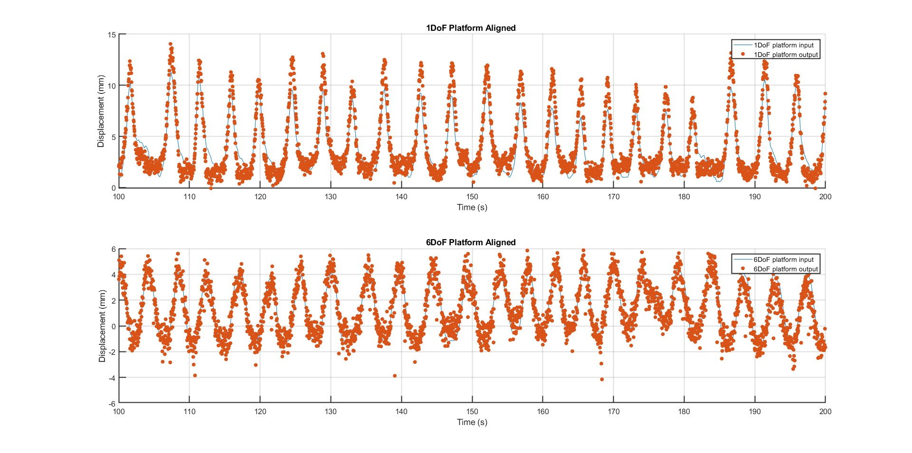

# **3.High_Motion**

|  |  |  |
| --- | --- | --- |
| mm | **1DoF (0.2s)** | **6DoF** |
| **Mean** | 0.0 | -0.1 |
| **Std** | 1.2 | 0.7 |
| **1st percentile** | -2.8 | -1.9 |
| **99th percentile** | 3.3 | 1.6 |
| **Latency of the combined system (s)** | | |
| **Mean (RMSE method)** | 0.30 | |
| **Mean (1st peak method)** | 0.21 | |

## 0.2s delay

|  |  |  |  |  |  |  |
| --- | --- | --- | --- | --- | --- | --- |
|  | **1DoF platform** | | | **6DoF platform** | | |
| Tests | Test 1 | Test 2 | Test 3 | Test 1 | Test 2 | Test 3 |
| Mean (mm) | 0.2 | -0.2 | 0.1 | -0.3 | 0.1 | -0.0 |
| Std (mm) | 1.3 | 1.2 | 1.2 | 0.7 | 0.8 | 0.7 |
| 1st percentile (mm) | -2.8 | -3.0 | -2.7 | -2.0 | -2.0 | -1.7 |
| 99th percentile (mm) | 3.7 | 3.1 | 3.0 | 1.4 | 1.8 | 1.7 |
| Latency (RMSE) (s) | 0.51 | 0.21 | 0.19 | - | | |
| Latency (1st peak) (s) | 0.4 | 0.1 | 0.12 |  | | |

## 0.4s delay

|  |  |  |  |  |  |  |
| --- | --- | --- | --- | --- | --- | --- |
|  | **1DoF platform** | | | **6DoF platform** | | |
| Tests | Test 1 | Test 2 | Test 3 | Test 1 | Test 2 | Test 6 |
| Mean (mm) | -0.2 | 0.4 | 0.2 | -0.2 | 0.1 | 0.0 |
| Std (mm) | 1.6 | 1.7 | 1.7 | 0.8 | 0.8 | 0.9 |
| 1st percentile (mm) | -3.8 | -3.1 | -3.2 | -2.0 | -1.8 | -1.9 |
| 99th percentile (mm) | 4.3 | 5.3 | 5.1 | 1.9 | 2.0 | 2.0 |
| Latency (RMSE) (s) | 0.17 | 0.45 | 0.04 |  | | |
| Latency (1st peak) (s) | -0.1 | 0.38 | -0.05 |  | | |

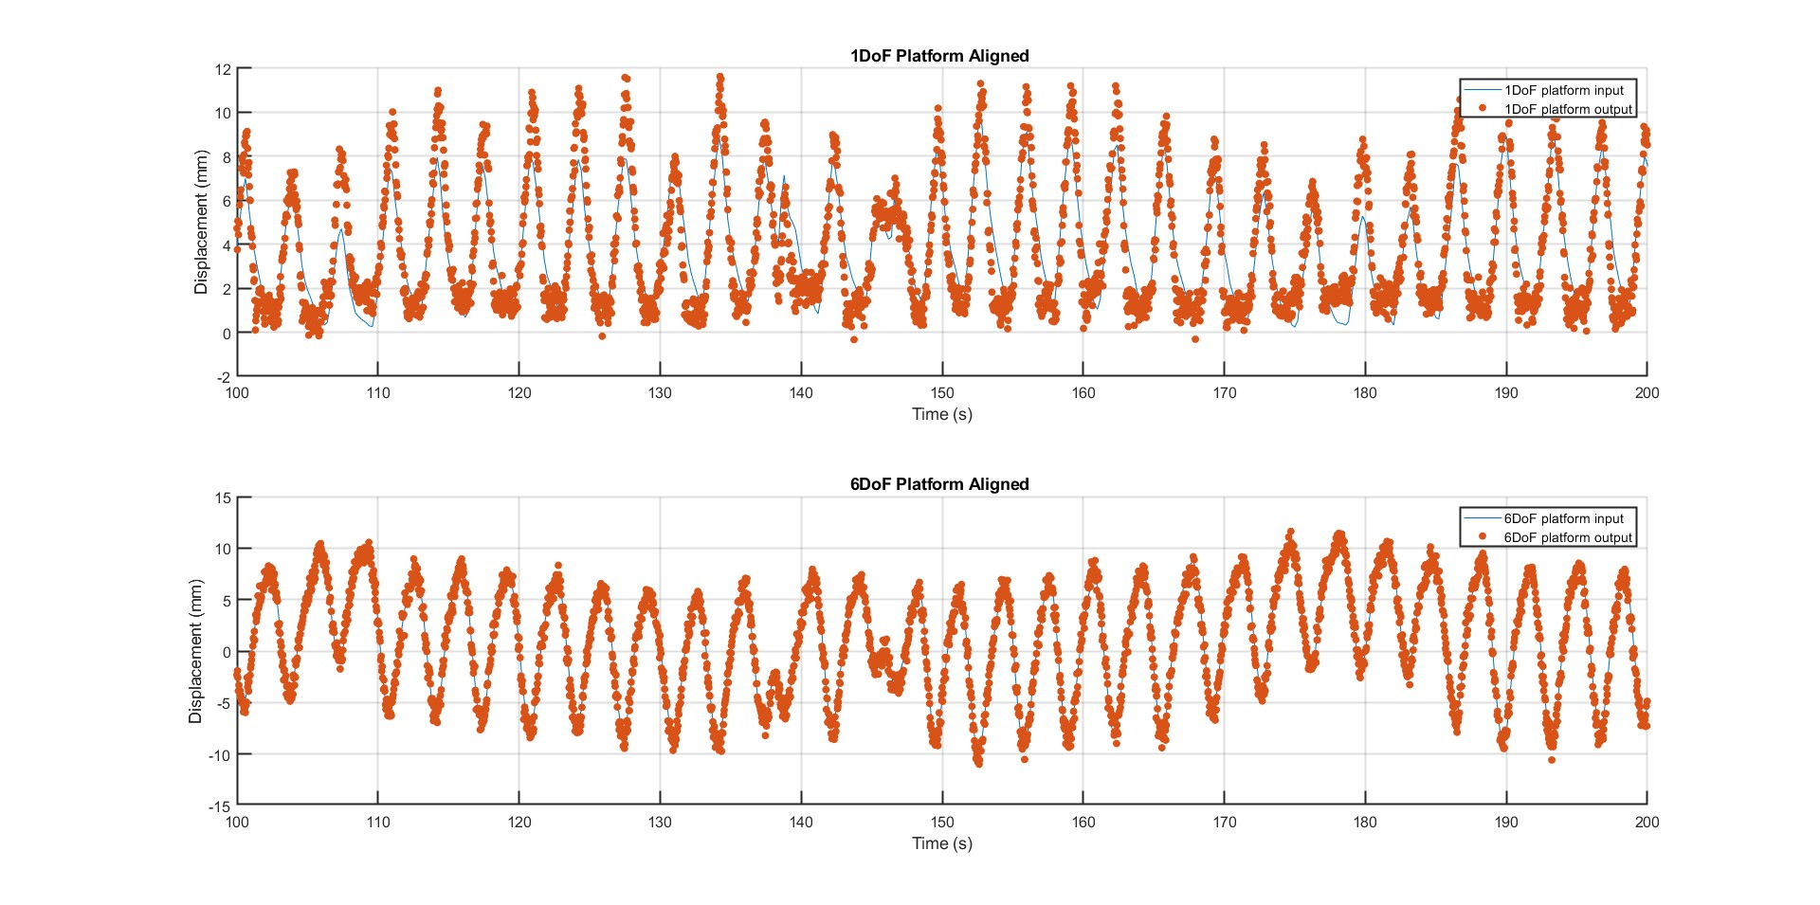

# **4.Mean_Complexity**

|  |  |  |
| --- | --- | --- |
| mm | **1DoF (0.2s)** | **6DoF** |
| **Mean** | 0.1 | 0.0 |
| **Std** | 1.1 | 0.7 |
| **1st percentile** | -2.3 | -1.6 |
| **99th percentile** | 3.2 | 1.7 |
| **Latency of the combined system (s)** | | |
| **Mean (RMSE method)** | 0.07 | |
| **Mean (1st peak method)** | 0.07 | |

## 0.2s delay

|  |  |  |  |  |  |  |
| --- | --- | --- | --- | --- | --- | --- |
|  | **1DoF platform** | | | **6DoF platform** | | |
| Tests | Test 1 | Test 2 | Test 3 | Test 1 | Test 2 | Test 3 |
| Mean (mm) | 0.3 | 0.4 | 0.3 | 0.0 | -0.1 | 0.1 |
| Std (mm) | 1.1 | 1.1 | 1.1 | 0.7 | 0.7 | 0.7 |
| 1st percentile (mm) | -2.4 | -2.3 | -2.2 | -1.7 | -1.6 | -1.6 |
| 99th percentile (mm) | 3.2 | 3.2 | 3.1 | 1.8 | 1.6 | 1.7 |
| Latency (RMSE) (s) | -0.03 | -0.11 | -0.12 |  | | |
| Latency (1st peak) (s) | 0.1 | 0.01 | 0.1 |  | | |

## 0.4s delay

|  |  |  |  |  |  |  |
| --- | --- | --- | --- | --- | --- | --- |
|  | **1DoF platform** | | | **6DoF platform** | | |
| Tests | Test 1 | Test 2 | Test 3 | Test 1 | Test 2 | Test 3 |
| Mean (mm) | -0.0 | 0.1 | 0.0 | -0.1 | 0.1 | -0.1 |
| Std (mm) | 1.6 | 1.7 | 1.7 | 0.8 | 0.8 | 0.8 |
| 1st percentile (mm) | -4. | -4 | -3.9 | -2.0 | -1.8 | -2.0 |
| 99th percentile (mm) | 4 | 4.6 | 4.6 | 1.7 | 2.0 | 2.0 |
| Latency (RMSE) (s) | 0.31 | 0.17 | 0.19 |  | | |
| Latency (1st method) (s) | 0.25 | 0.23 | 0.25 |  | | |

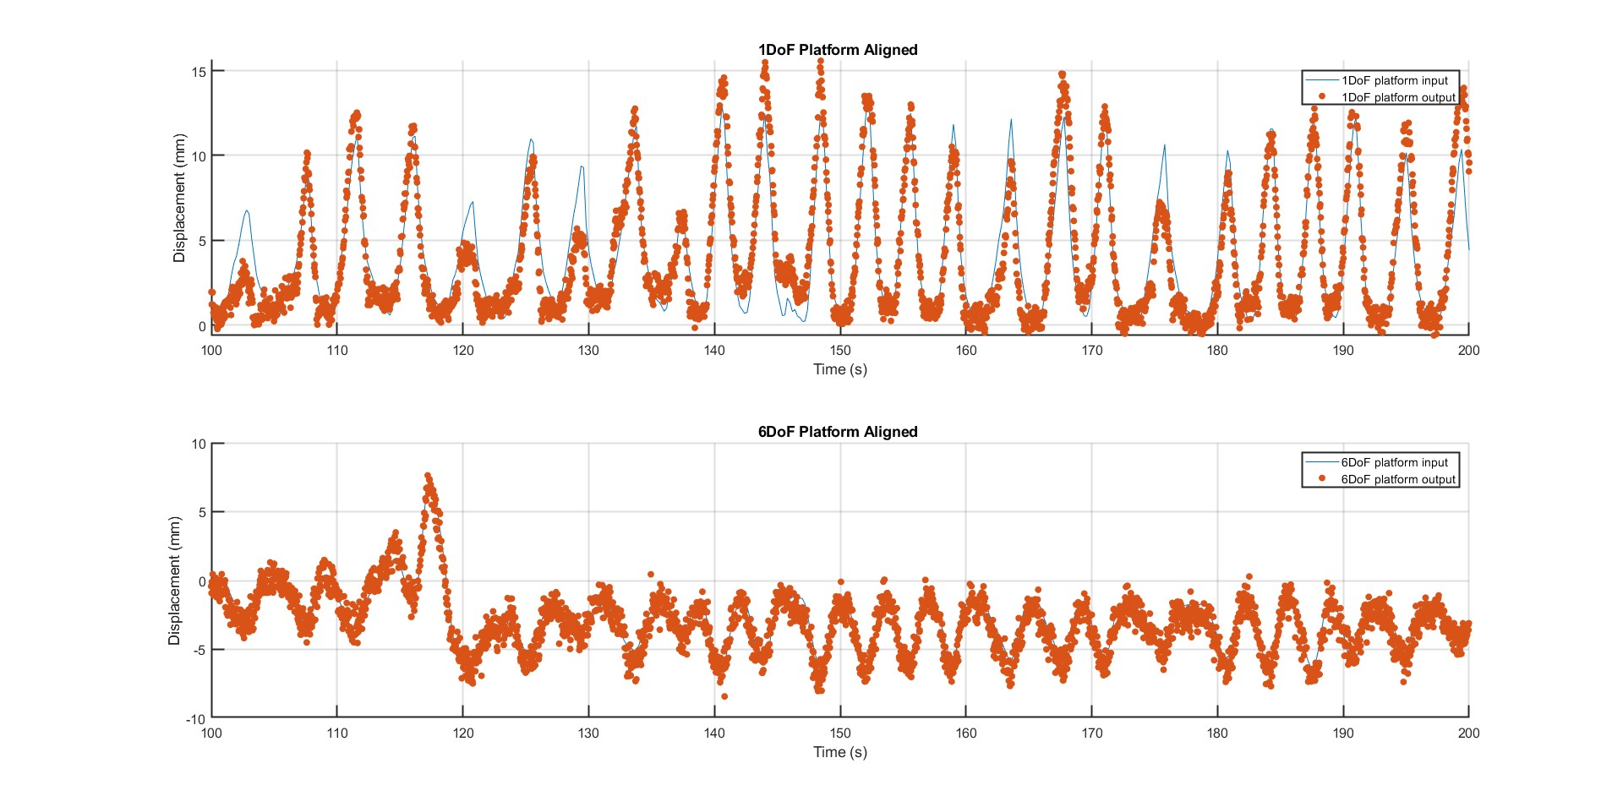

# **5.High_Complexity**

|  |  |  |
| --- | --- | --- |
| mm | **1DoF (0.2s)** | **6DoF** |
| **Mean** | 0.2 | 0.2 |
| **Std** | 1.9 | 0.7 |
| **1st percentile** | -4.4 | -1.5 |
| **99th percentile** | 4.6 | 1.8 |
| **Latency of the combined system (s)** | | |
| **Mean (RMSE method)** | 0.08 | |
| **Mean (1st peak method)** | 0.12 | |

## 0.2s delay

|  |  |  |  |  |  |  |
| --- | --- | --- | --- | --- | --- | --- |
|  | **1DoF platform** | | | **6DoF platform** | | |
| Tests | Test 1 | Test 2 | Test 3 | Test 1 | Test 2 | Test 3 |
| Mean (mm) | 0.4 | 0.5 | -0.2 | 0.3 | 0.2 | 0.0 |
| Std (mm) | 1.9 | 1.9 | 1.9 | 0.7 | 0.7 | 0.7 |
| 1st percentile (mm) | -4.5 | -4.2 | -4.6 | -1.3 | -1.6 | -1.7 |
| 99th percentile (mm | 4.7 | 4.7 | 4.3 | 1.9 | 1.8 | 1.6 |
| Latency (RMSE) (s) | 0.27 | 0.04 | -0.07 |  | | |
| Latency (1st peak) (s) | 0.25 | 0.05 | 0.05 |  | | |

## 0.4s delay

|  |  |  |  |  |  |  |
| --- | --- | --- | --- | --- | --- | --- |
|  | **1DoF platform** | | | **6DoF platform** | | |
| Tests | Test 1 | Test 2 | Test 3 | Test 1 | Test 2 | Test 3 |
| Mean (mm) | 0.1 | 0.7 | 0.5 | 0.2 | 0.1 | 1.0 |
| Std (mm) | 1.9 | 2.0 | 2.2 | 0.8 | 0.9 | 0.9 |
| 1st percentile (mm) | -3.8 | -3.5 | -4.3 | -1.7 | -1.9 | -0.9 |
| 99th percentile (mm) | 5.0 | 5.8 | 6.1 | 2.3 | 2.1 | 3.0 |
| Latency (RMSE) (s) | 0.33 | -0.02 | 0.32 |  | | |
| Latency (1st peak) (s) | 0.4 | 0.03 | 0.35 |  | | |

